Lab 4: Working with Web tables & Web Forms

# **1. Web tables**

## courselist4.htm

1. <html>
2. <head>
3. <title>This is the Course List</title>
4. </head>
5. <body>
6. <img src="./Nwlogo.jpg" alt="Vanier College">
7. <h1>Vanier College</h1>
8. <h3>Course List Schedule</h3>
9. <table class="listcourse" border="1">
10. <tr>
11. <th>Time</th>
12. <th>Fall 2022</th>
13. <th>Winter 2022</th>
14. </tr>
15. <tr>
16. <th>Monday</th>
17. <td>HTML and Internet Programming</td>
18. <td>Analysis of The Work Function & Communication</td>
19. </tr>
20. <tr>
21. <th>Tuesday</th>
22. <td colspan="2">Association of Law Notions to the Professional Practice</td>
23. </tr>
24. <tr>
25. <th>Wednesday</th>
26. <td>International Business</td>
27. <td>Marketing and Communication</td>
28. </tr>
29. </table>
30. </body>
31. </html>

## courselist4.htm Screenshot

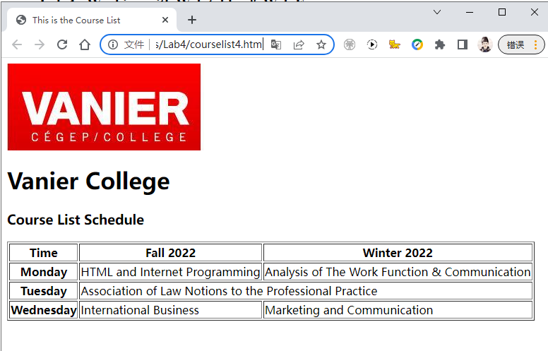

## courselist5.htm

1. <html>
2. <head>
3. <title>This is the Course List</title>
4. </head>
5. <body>
6. <img src="./Nwlogo.jpg" alt="Vanier College">
7. <h1>Vanier College</h1>
8. <h3>Course List Schedule</h3>
9. <table class="listcourse" border="1">
10. <tr>
11. <th>Time</th>
12. <th>Fall 2022</th>
13. <th>Winter 2022</th>
14. </tr>
15. <tr>
16. <th>Monday</th>
17. <td>HTML and Internet Programming</td>
18. <td>Analysis of The Work Function & Communication</td>
19. </tr>
20. <tr>
21. <th rowspan="2">Tuesday</th>
22. <td colspan="2">Association of Law Notions to the Professional Practice</td>
23. </tr>
24. <tr>
25. <td>International Business</td>
26. <td>Marketing and Communication</td>
27. </tr>
28. </table>
29. </body>
30. </html>

## Courselist5.htm Screenshot

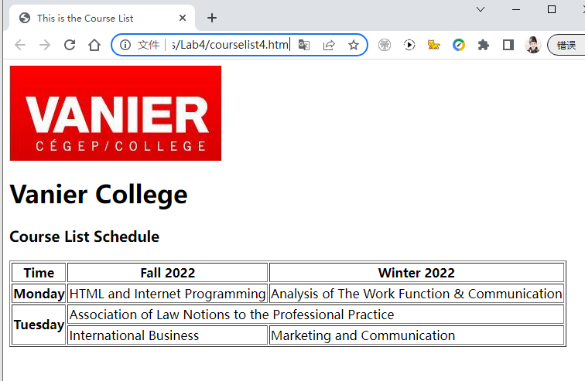

## courselist6.htm

1. <html>
2. <head>
3. <title>This is the Course List</title>
4. </head>
5. <body>
6. <img src="./Nwlogo.jpg" alt="Vanier College">
7. <h1>Vanier College</h1>
8. <h3>Course List Schedule</h3>
9. <table class="listcourse" border="1">
10. <tr>
11. <th>Day</th>
12. <th>Time</th>
13. <th>Fall 2022</th>
14. <th>Winter 2022</th>
15. </tr>
16. <tr>
17. <th>Monday</th>
18. <td>9H-12H</td>
19. <td>HTML and Internet Programming</td>
20. <td>Analysis of The Work Function & Communication</td>
21. </tr>
22. <tr>
23. <th rowspan="2">Tuesday</th>
24. <td>9H-12H</td>
25. <td colspan="2">Association of Law Notions to the Professional Practice</td>
26. </tr>
27. <tr>
28. <td>13H-16H</td>
29. <td>International Business</td>
30. <td>Marketing and Communication</td>
31. </tr>
32. </table>
33. </body>
34. </html>

\

## courselist6.htm Screenshot

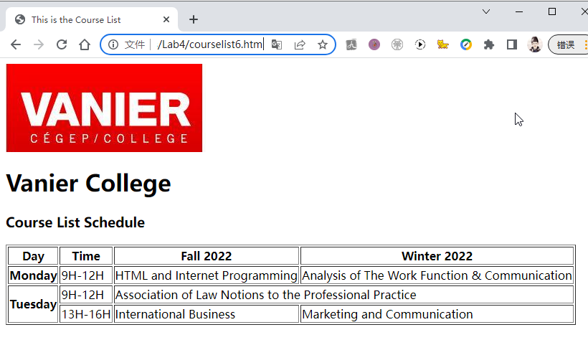

# **2. Introducing Web Forms**

• Parts of a Web Form and How the Form is Processed by Server-side Scripts

## Register_form1.html

1. <html>
2. <head>
3. <title>Registration Form</title>
4. </head>
5. <body>
6. <form name="registerForm" id="registerForm" action="RegisterScript.php">
7. <p>This is a Web form ...</p>
8. </form>
9. </body>
10. </html>

## Register_form1.html Screenshot

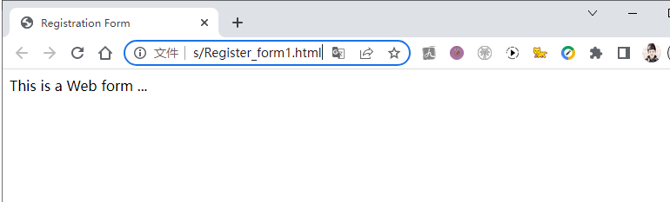

• Creating a Field Set

## Register_form2.html

1. <html>
2. <head>
3. <title>Registration Form</title>
4. </head>
5. <body>
6. <form name="registerForm" id="registerForm" action="RegisterScript.php">
7. <fieldset> This is a Fields of Contact information ...
8. </fieldset>
9. <fieldset> This is a Fields of Electricity consumption ...
10. </fieldset>
11. <fieldset> This is a Fields of Feedback information ...
12. </fieldset>
13. </form>
14. </body>
15. </html>

## Register_form2.html Screenshot

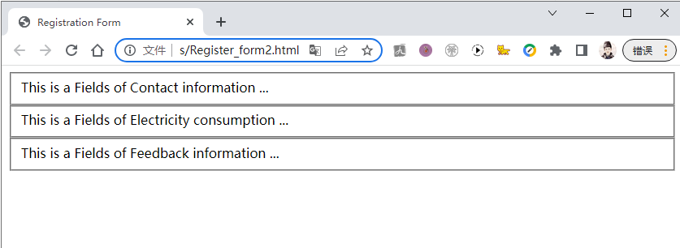

• Creating a Label for each Field Set

## Register_form3.html

1. <html>
2. <head>
3. <title>Registration Form</title>
4. </head>
5. <body>
6. <form name="registerForm" id="registerForm" action="RegisterScript.php">
7. <fieldset id="contact">
8. <legend>Contact information</legend>
9. </fieldset>
10. <fieldset>
11. <legend>Power Consumption</legend>
12. </fieldset>
13. <fieldset>
14. <legend>Feedback</legend>
15. </fieldset>
16. </form>
17. </body>
18. </html>

## Register_form3.html Screenshot

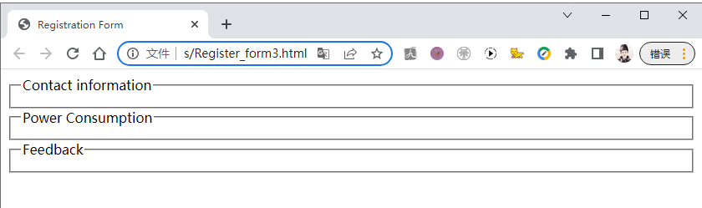

# **3. Creating Input Boxes**

• Creating control elements

## Register_form4.html

1. <html>
2. <head>
3. <title>Registration Form</title>
4. </head>
5. <body>
6. <form name="registerForm" id="registerForm" action="RegisterScript.php">
7. <fieldset id="contact">
8. <legend>Contact information</legend>
9. First Name: <input type="text" id="fame"/>
10. Last Name: <input type="text" id="lame"/>
11. Phone: <input type="text" id="phone"/>
12. Street Address: <input type="text" id="sadd"/>
13. </fieldset>
14. <fieldset>
15. <legend>Power Consumption</legend>
16. </fieldset>
17. <fieldset>
18. <legend>Feedback</legend>
19. </fieldset>
20. </form>
21. </body>
22. </html>

## Register_form4.html Screenshot

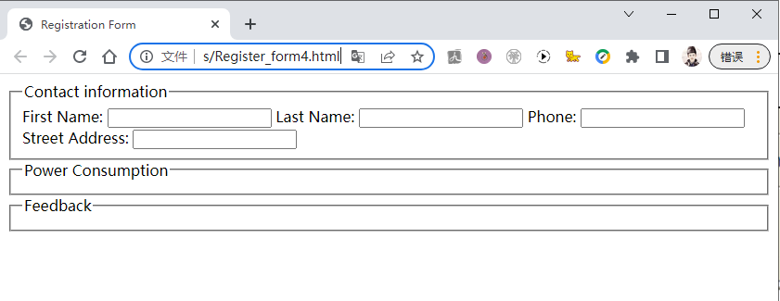

• Adding Field Labels

## Register_form5.html

1. <html>
2. <head>
3. <title>Registration Form</title>
4. </head>
5. <body>
6. <form name="registerForm" id="registerForm" action="RegisterScript.php">
7. <fieldset id="contact">
8. <legend>Contact information</legend>
9. <label>First Name:
10. <input type="text" id="fame"/>
11. </label>
12. <label>Last Name:
13. <input type="text" id="lame"/>
14. </label>
15. <label>Phone:
16. <input type="text" id="phone"/>
17. </label>
18. <label>Street Address:
19. <input type="text" id="sadd"/>
20. </label>
21. </fieldset>
22. <fieldset>
23. <legend>Power Consumption</legend>
24. </fieldset>
25. <fieldset>
26. <legend>Feedback</legend>
27. </fieldset>
28. </form>
29. </body>
30. </html>

## Register_form5.html Screenshot

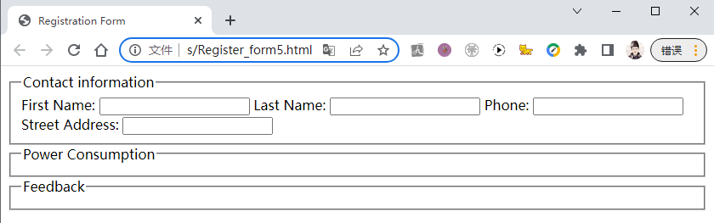

# **4. Working with Form Styles and HTML attributes**

## Register_form6.html

1. <html>
2. <head>
3. <title>Registration Form</title>
4. <link href="./formformat6.css" rel="stylesheet" type="text/css" />
5. </head>
6. <body>
7. <form name="registerForm" id="registerForm" action="RegisterScript.php">
8. <fieldset id="contact">
9. <legend>Contact information</legend>
10. <label class="labelblock">First Name:
11. <input type="text" id="fame"/>
12. </label>
13. <label class="labelblock">Last Name:
14. <input type="text" id="lame"/>
15. </label>
16. <label class="labelblock">Phone:
17. <input type="text" id="phone"/>
18. </label>
19. <label class="labelblock">Street Address:
20. <input type="text" id="sadd"/>
21. </label>
22. </fieldset>
23. <fieldset>
24. <legend>Power Consumption</legend>
25. </fieldset>
26. <fieldset>
27. <legend>Feedback</legend>
28. </fieldset>
29. </form>
30. </body>
31. </html>

## formformat6.css

1. */\**
2. CSS file for Style formatting
3. Review 6: Web Form
4. */
5. label.labelblock {display: block;}

## Register_form6.html Screenshot

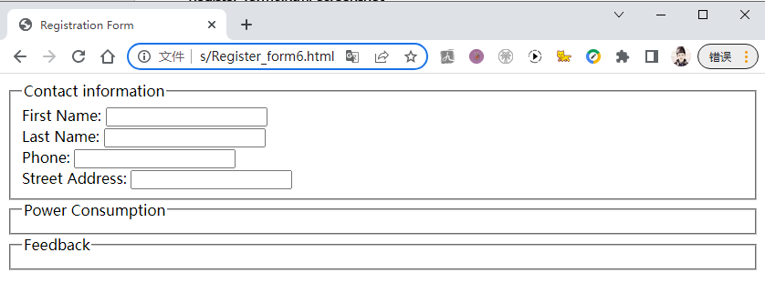

• **Set Margin for the control Elements**

## Register_form7.html

1. <html>
2. <head>
3. <title>Registration Form</title>
4. <link href="./formformat7.css" rel="stylesheet" type="text/css" />
5. </head>
6. <body>
7. <form name="registerForm" id="registerForm" action="RegisterScript.php">
8. <fieldset id="contact">
9. <legend>Contact information</legend>
10. <label class="labelblock">First Name:
11. <input type="text" id="fame"/>
12. </label>
13. <label class="labelblock">Last Name:
14. <input type="text" id="lame"/>
15. </label>
16. <label class="labelblock">Phone:
17. <input type="text" id="phone"/>
18. </label>
19. <label class="labelblock">Street Address:
20. <input type="text" id="sadd"/>
21. </label>
22. </fieldset>
23. <fieldset>
24. <legend>Power Consumption</legend>
25. </fieldset>
26. <fieldset>
27. <legend>Feedback</legend>
28. </fieldset>
29. </form>
30. </body>
31. </html>

## formformat7.css

1. */\**
2. CSS file for Style formatting
3. Review 6: Web Form
4. */
5. label.labelblock {display: block; position: relative; left: 12px; top: 0px;}
6. label.labelblock input {position: absolute; left: 150px;}

## Register_form7.html Screenshot

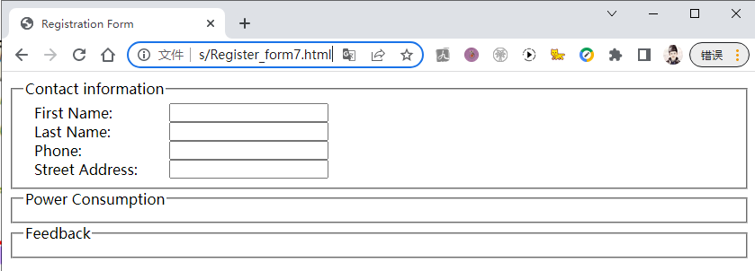

• Mark Require Fields

## Register_form12.html

1. <html>
2. <head>
3. <title>Registration Form</title>
4. <link href="./formformat12.css" rel="stylesheet" type="text/css" />
5. </head>
6. <body>
7. <form name="registerForm" id="registerForm" action="RegisterScript.php">
8. <fieldset id="AddressOptions">
9. <legend>Address For</legend>
10. <label class="Optionlabel">Home
11. <input type="radio" id="homeType" name="addressType" value="home" />
12. </label>
13. <label class="Optionlabel">Business
14. <input type="radio" id="busType" name="addressType" value="business" />
15. </label>
16. <select name="addressType" id="addressType" size="2">
17. <option value="homeType">Home</option>
18. <option value="busType">Business</option>
19. </select>
20. </fieldset>
21. <fieldset id="contact">
22. <legend>Contact information</legend>
23. <label class="labelblock">
24. First Name:<span>*</span>
25. <input type="text" id="fame"/>
26. </label>
27. <label class="labelblock">
28. Last Name:<span>*</span>
29. <input type="text" id="lame"/>
30. </label>
31. <label class="labelblock">
32. Phone:<span>*</span>
33. <input type="text" id="phone"/>
34. </label>
35. <label class="labelblock">
36. Street Address:<span>*</span>
37. <input type="text" id="sadd"/>
38. </label>
39. <label class="indenlabel">
40. City:<span>*</span>
41. <input type="text" id="city"/>
42. </label>
43. <label class="indenlabel">
44. State:<span>*</span>
45. <input type="text" id="state"
46. value="QC" maxlength="2" />
47. </label>
48. <label class="indenlabel">
49. ZIP:<span>*</span>
50. <input type="text" id="zip" maxlength="10"/>
51. </label>
52. </fieldset>
53. <fieldset>
54. <legend>Power Consumption</legend>
55. <label class="labelblock">
56. Electricity Consumption:<span>*</span>
57. <input type="text" id="elec" />
58. </label>
59. <label class="labelblock">
60. Gaz Consumption:<span>*</span>
61. <input type="text" id="gaz"/>
62. </label>
63. </fieldset>
64. <fieldset>
65. <legend>Feedback</legend>
66. <label class="labelblock">
67. Enter Your Comments:<span>*</span>
68. <textarea name="comment" id="comment"></textarea>
69. </label>
70. </fieldset>
71. </form>
72. </body>
73. </html>

## Register_form12.html Screenshot

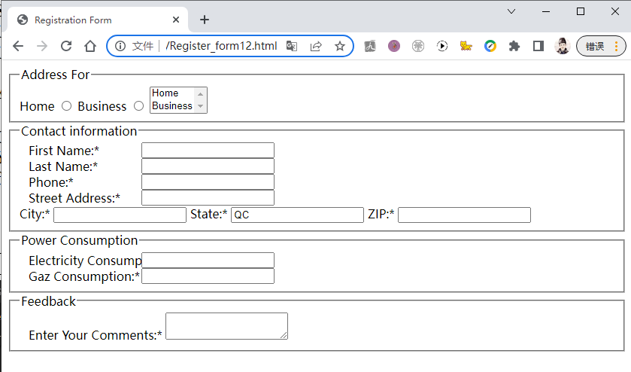

# **5. Creating Option Button , Selection List, Check Boxes**

## Register_form16.html

1. <html>
2. <head>
3. <title>Registration Form</title>
4. <link href="./formformat16.css" rel="stylesheet" type="text/css" />
5. </head>
6. <body>
7. <form name="registerForm" id="registerForm" action="RegisterScript.php">
8. <fieldset id="AddressOptions">
9. <legend>Address For</legend>
10. <label class="Optionlabel">Home
11. <input type="radio" id="homeType" name="addressType" value="home" />
12. </label>
13. <label class="Optionlabel">Business
14. <input type="radio" id="busType" name="addressType" value="business" />
15. </label>
16. <select name="addressType" id="addressType" size="2">
17. <option value="homeType">Home</option>
18. <option value="busType">Business</option>
19. </select>
20. </fieldset>
21. <fieldset id="contact">
22. <legend>Contact information</legend>
23. <label class="labelblock">
24. First Name:<span>*</span>
25. <input type="text" id="fame"/>
26. </label>
27. <label class="labelblock">
28. Last Name:<span>*</span>
29. <input type="text" id="lame"/>
30. </label>
31. <label class="labelblock">
32. Phone:<span>*</span>
33. <input type="text" id="phone"/>
34. </label>
35. <label class="labelblock">
36. Street Address:<span>*</span>
37. <input type="text" id="sadd"/>
38. </label>
39. <label class="indenlabel">
40. City:<span>*</span>
41. <input type="text" id="city"/>
42. </label>
43. <label class="indenlabel">
44. State:<span>*</span>
45. <input type="text" id="state"
46. value="QC" maxlength="2" />
47. </label>
48. <label class="indenlabel">
49. ZIP:<span>*</span>
50. <input type="text" id="zip" maxlength="10"/>
51. </label>
52. </fieldset>
53. <fieldset>
54. <legend>Power Consumption</legend>
55. <label class="labelblock">
56. Electricity Consumption:<span>*</span>
57. <input type="text" id="elec" />
58. </label>
59. <label class="labelblock">
60. Gaz Consumption:<span>*</span>
61. <input type="text" id="gaz"/>
62. </label>
63. </fieldset>
64. <fieldset>
65. <legend>Feedback</legend>
66. <label class="labelfeedback">
67. <input type="checkbox" id="message" name="message" value="yes">
68. Do you want to receive update email messages?
69. </label>
70. <label class="labelfeedback">
71. Enter Your Comments:<span>*</span>
72. <textarea name="comment" id="comment" rows="5" cols="60">
73. Please Insert Your Comments here
74. </textarea>
75. </label>
76. </fieldset>
77. </form>
78. </body>
79. </html>

## formformat16.css

1. label.labelblock {display: block; position: relative; left: 12px; top: 0px;}
2. label.labelblock input {position: absolute; left: 150px;}
3. #registerForm span {color: red;}
4. label.indenlabel {position: relative; left: 150px;}
5. #fname, #lname, #sadd {width: 25em;}
6. #phone, #city {width: 10em;}
7. #state {width: 3em;}
8. #zip {width: 7em;}
9. label.Optionlabel {display: block;
10. position: relative;
11. left: 150px; top: 0px;}
12. #AddressOptions {width: 280px;}
13. #AddressOptions select {position: relative;
14. left: 150px; top: 0px;}

## Register_form16.html Screenshot

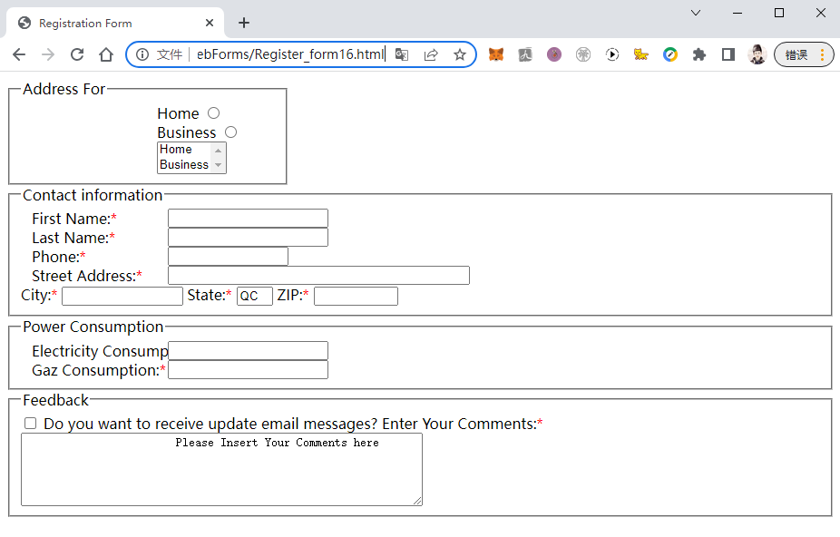

# **6. Working with Form Buttons**

• Creating a Command Button

## Register_form18.html

1. <html>
2. <head>
3. <title>Registration Form</title>
4. <link href="./formformat18.css" rel="stylesheet" type="text/css" />
5. </head>
6. <body>
7. <form name="registerForm" id="registerForm" action="RegisterScript.php">
8. <fieldset id="AddressOptions">
9. <legend>Address For</legend>
10. <label class="Optionlabel">Home
11. <input type="radio" id="homeType" name="addressType" value="home" />
12. </label>
13. <label class="Optionlabel">Business
14. <input type="radio" id="busType" name="addressType" value="business" />
15. </label>
16. <select name="addressType" id="addressType">
17. <optgroup label="Canada">
18. <option>Quebec</option>
19. <option>Ontario</option>
20. <option>British Columbia</option>
21. </optgroup>
22. </select>
23. </fieldset>
24. <fieldset id="contact">
25. <legend>Contact information</legend>
26. <label class="labelblock">
27. First Name:<span>*</span>
28. <input type="text" id="fame"/>
29. </label>
30. <label class="labelblock">
31. Last Name:<span>*</span>
32. <input type="text" id="lame"/>
33. </label>
34. <label class="labelblock">
35. Phone:<span>*</span>
36. <input type="text" id="phone"/>
37. </label>
38. <label class="labelblock">
39. Street Address:<span>*</span>
40. <input type="text" id="sadd"/>
41. </label>
42. <label class="indenlabel">
43. City:<span>*</span>
44. <input type="text" id="city"/>
45. </label>
46. <label class="indenlabel">
47. State:<span>*</span>
48. <input type="text" id="state"
49. value="QC" maxlength="2" />
50. </label>
51. <label class="indenlabel">
52. ZIP:<span>*</span>
53. <input type="text" id="zip" maxlength="10"/>
54. </label>
55. </fieldset>
56. <fieldset>
57. <legend>Power Consumption</legend>
58. <label class="labelblock">
59. Electricity Consumption:<span>*</span>
60. <input type="text" id="elec" />
61. </label>
62. <label class="labelblock">
63. Gaz Consumption:<span>*</span>
64. <input type="text" id="gaz"/>
65. </label>
66. </fieldset>
67. <fieldset>
68. <legend>Feedback</legend>
69. <label class="labelfeedback">
70. <input type="checkbox" id="message" name="message" value="yes">
71. Do you want to receive update email messages?
72. </label>
73. <label class="labelfeedback">
74. Enter Your Comments:<span>*</span>
75. <textarea name="comment" id="comment" rows="5" cols="60">
76. Please Insert Your Comments here
77. </textarea>
78. </label>
79. </fieldset>
80. <input type="submit" value="Register" />
81. <input type="reset" value="Cancel" />
82. </form>
83. </body>
84. </html>

## formformat18.css

1. label.labelblock {display: block; position: relative; left: 12px; top: 0px;}
2. label.labelblock input {position: absolute; left: 150px;}
3. #registerForm span {color: red;}
4. label.indenlabel {position: relative; left: 150px;}
5. #fname, #lname, #sadd {width: 25em;}
6. #phone, #city {width: 10em;}
7. #state {width: 3em;}
8. #zip {width: 7em;}
9. label.Optionlabel {display: block;
10. position: relative;
11. left: 150px; top: 0px;}
12. #AddressOptions {width: 280px;}
13. #AddressOptions select {position: relative;
14. left: 150px; top: 0px;}
15. label.labelfeedback {display: block;
16. position: relative;
17. left: 12px; top: 0px;}

## Register_form18.html Screenshot

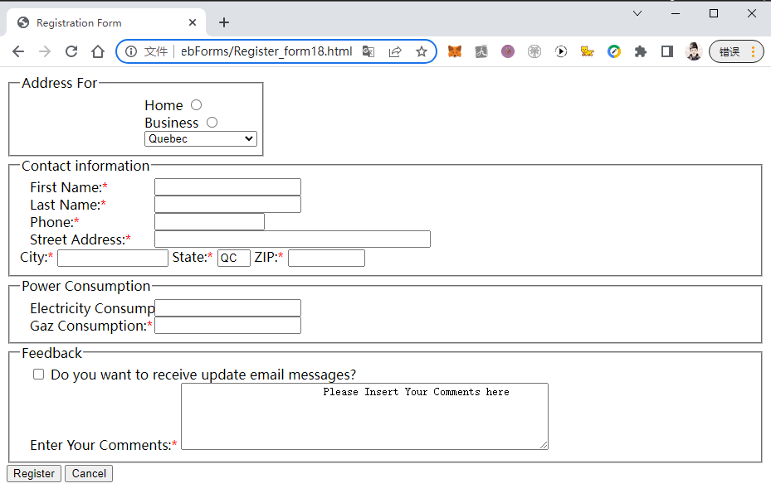

# **7. Review Case Problem: Create Donation Form**

## DonationForm.htm

1. <html>
2. <head>
3. *<!--*
4. New Perspectives on HTML and XHTML
5. Tutorial 6
6. Review Assignment
8. The Lighthouse Volunteer Page
9. Author: Qingjun Bao
10. Date:   2022-07-21
12. Filename:         volunteer.htm
13. Supporting files: back.jpg, left.jpg, lhouse.jpg, main.css
14. right.jpg, Donationformat.css
16. -->
18. <title>Lighthouse Volunteer Form</title>
19. <link href="main.css" rel="stylesheet" type="text/css" />
20. <link href="Donationformat.css" rel="stylesheet" type="text/css" />
21. </head>
23. <body>
24. <div id="head"><img src="lhouse.jpg" alt="The Lighthouse" /></div>
26. <div id="links">
27. <ul>
28. <li><a href="#">home</a></li>
29. <li><a href="#">projects</a></li>
30. <li><a href="#">upcoming events</a></li>
31. <li><a href="#">community links</a></li>
32. <li><a href="#">staff</a></li>
33. <li><a href="#">donations</a></li>
34. <li><a href="#">volunteers</a></li>
35. <li><a href="#">contact info</a></li>
36. </ul>
37. </div>
39. <div id="mainContent">
40. <div id="leftColumn">
41. <p>The success of The Lighthouse reflects the dedication and support of members of
42. the community who have helped make our dream a reality. We cannot continue to
43. operate without contributions from people like you.
44. </p>
45. <p>You can make a tax-deductible donation online using your American Express,
46. Discover, Master, or Visa card. Please fill out the form on this page.
47. </p>
48. <p>The Lighthouse is always looking for volunteers. We especially need help in the
49. following areas:
50. </p>
51. <ul>
52. <li>Mechanics</li>
53. <li>Carpenters</li>
54. <li>Electricians</li>
55. <li>Cooks</li>
56. <li>Comnputer technicians</li>
57. <li>Babysitters</li>
58. <li>Data entry persons</li>
59. </ul>
60. <p>and <a href="#">many others</a>. Please consider donating your time and talents to your community
61. and your neighbors.
62. </p>
63. <p>Thank you so much for your generosity!
64. </p>
66. <p>— Terry Ives<br />
67. Director, <i>The Lighthouse</i></p>
68. </div>
70. <form name="registerForm" id="registerForm" action="RegisterScript.php">
71. <div id="rightColumn">
72. <h1>Donation Form</h1>
73. <p><span>*</span> indicates required information</p>
75. <fieldset id="contact">
76. <legend>Contact information</legend>
78. <fieldset id="AddressOptions">
79. <legend>Address For</legend>
80. <label class="Optionlabel">Home
81. <input type="radio" id="homeType" name="addressType" value="home" />
82. </label>
83. <label class="Optionlabel">Business
84. <input type="radio" id="busType" name="addressType" value="business" />
85. </label>
86. </fieldset>
88. <label class="labelblock">
89. First Name<span>*</span>
90. <input type="text" id="fname"/>
91. </label>
92. <label class="labelblock">
93. Last Name<span>*</span>
94. <input type="text" id="lname"/>
95. </label>
96. <label class="labelblock">
97. Phone<span>*</span>
98. <input type="text" id="phone"/>
99. </label>
100. <label class="labelblock">
101. Street Address<span>*</span>
102. <input type="text" id="sadd"/>
103. </label>
104. <label class="indenlabel">
105. City<span>*</span>
106. <input type="text" id="city" value="St. Peters"/>
107. </label>
108. <label class="indenlabel">
109. State<span>*</span>
110. <input type="text" id="state"
111. value="MO" maxlength="2" />
112. </label>
113. <label class="indenlabel">
114. ZIP<span>*</span>
115. <input type="text" id="zip" maxlength="10"/>
116. </label>
117. </fieldset>
118. <br>
120. <fieldset id="donation">
121. <legend>Donation information</legend>
122. <br>
123. <label class="labelblock">
124. Donation Amount<span>*</span>
125. <input type="text" id="damon"/>
126. </label>
128. <label class="labelblock">
129. Credit Card<span>*</span>
130. <select name="selCardType" id="selCardType">
131. <option value="express">American Express</option>
132. <option value="master">Master Card</option>
133. <option value="visa">Visa Card</option>
134. </select>
135. </label>
137. <label class="labelblock">
138. Cardholder Name<span>*</span>
139. <input type="text" id="dcardname"/>
140. </label>
141. <label class="labelblock">
142. Card Number<span>*</span>
143. <input type="text" id="dcardnum"/>
144. </label>
146. <label class="labelblock">
147. Expiration Date<span>*</span>
148. <select name="selMonth" id="selMonth">
149. <option value="jan">January (01)</option>
150. <option value="feb">February (02)</option>
151. <option value="mar">March (03)</option>
152. <option value="apr">April (04)</option>
153. <option value="may">May (05)</option>
154. <option value="jun">June (06)</option>
155. <option value="jul">July (07)</option>
156. <option value="aug">August (08)</option>
157. <option value="sep">September (09)</option>
158. <option value="oct">October (10)</option>
159. <option value="nov">November (11)</option>
160. <option value="dec">December (12)</option>
161. </select>
163. <select name="selYear" id="selYear">
164. <option value="y2022">2022</option>
165. <option value="y2023">2023</option>
166. <option value="y2024">2024</option>
167. <option value="y2025">2025</option>
168. <option value="y2026">2026</option>
169. <option value="y2027">2027</option>
170. <option value="y2028">2028</option>
171. </select>
172. </label>
174. <fieldset id="volunteerBefore">
175. <legend>Have you volunteered before?</legend>
176. <label class="Optionlabel">Yes
177. <input type="radio" id="volYes" name="volYes" value="Yes" />
178. </label>
179. <label class="Optionlabel">No
180. <input type="radio" id="volNo" name="volNo" value="No" />
181. </label>
182. </fieldset>
183. <br>
184. <fieldset id="canHelp">
185. <legend>I can help with the (check all that apply)</legend>
186. <table>
187. <tr>
188. <td><input type="checkbox" id="babySit" name="babySit" value="babySit">
189. <label for="babySit">Baby Sitting</label>
190. </td>
191. <td><input type="checkbox" id="cleaning" name="cleaning" value="cleaning">
192. <label for="cleaning">Cleaning</label>
193. </td>
194. <td><input type="checkbox" id="clerDuty" name="clerDuty" value="clerDuty">
195. <label for="clerDuty">Clerical Duties</label>
196. </td>
197. </tr>
198. <tr>
199. <td><input type="checkbox" id="eventPlan" name="eventPlan" value="eventPlan">
200. <label for="eventPlan">Event Planning</label>
201. </td>
202. <td><input type="checkbox" id="mailing" name="mailing" value="mailing">
203. <label for="mailing">Mailing</label>
204. </td>
205. <td><input type="checkbox" id="maintan" name="maintan" value="maintan">
206. <label for="maintan">Maintenance</label>
207. </td>
208. </tr>
209. <tr>
210. <td><input type="checkbox" id="mealPrep" name="mealPrep" value="mealPrep">
211. <label for="mealPrep">Meal Preparation</label>
212. </td>
213. <td><input type="checkbox" id="tutoring" name="tutoring" value="tutoring">
214. <label for="tutoring">Tutoring</label>
215. </td>
216. <td><input type="checkbox" id="website" name="website" value="website">
217. <label for="website">Web Site</label>
218. </td>
219. </tr>
220. </table>
221. </fieldset>
222. </fieldset>
223. <br>
224. <fieldset id="feedback">
225. <legend>Feedback</legend>
226. <input type="checkbox" id="interestVol" name="interestVol" value="interestVol">
227. <label for="interestVol">I'm interested in volunteering at The Lighthouse.</label>
228. <label class="labelfeedback">
229. Comments <br><br>
230. <textarea name="comment" id="comment" rows="5" cols="60">
231. </textarea>
232. </label>
233. </fieldset>
234. <br>
235. <input type="submit" value="Submit Donation" />
236. <input type="reset" value="Cancel" />
237. </div>
238. </form>
239. <address>
240. The Lighthouse &bull;
241. 150 Cavates Rd. &bull;
242. St. Peters, MO  63376 &bull;
243. (636) 555 - 4477
244. </address>
245. </div>
246. </body>
247. </html>

## Donationformat.css

1. #AddressOptions {position: relative; width: 180px; left: 150px;
2. margin: 0 0 10 0;}
3. #canHelp {position: relative; width: 450px; height: 100px;
4. margin: 0 0 10 0;}
5. label.labelfeedback {display: block;
6. position: relative;
7. height: 130px;
8. left: 0px; top: 10px;}
9. table {font-size: smaller ;}
10. table, tr, td {border: 0px;}
11. td {width: 180px;}

## DonationForm.htm Screenshot

